Installing Web Servers and Application Server.

1.Installing Nginx:
First let’s update the packages:
Yum update is the command
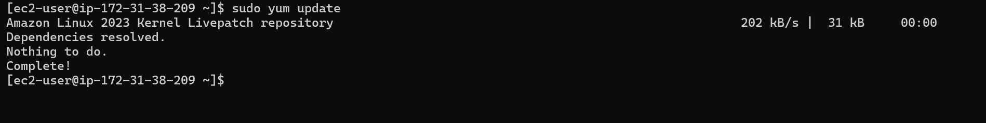
Let’s switch to root so the we do not have any permission challenges.
Now let’s install nginx
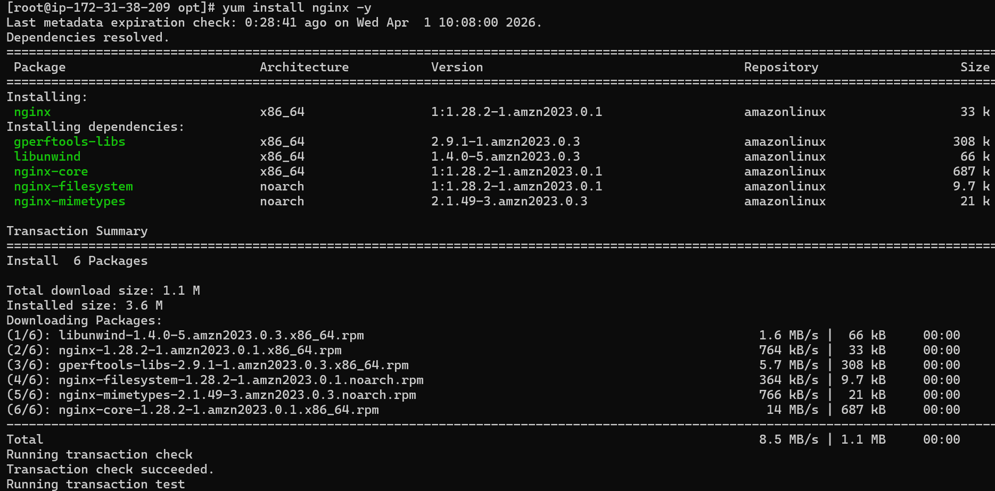
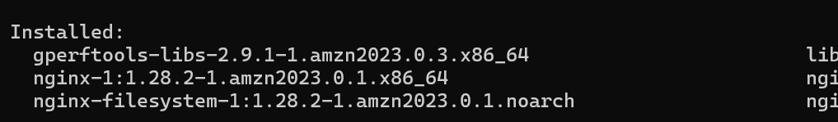
Nginx is now installed
Let’s start the nginx service

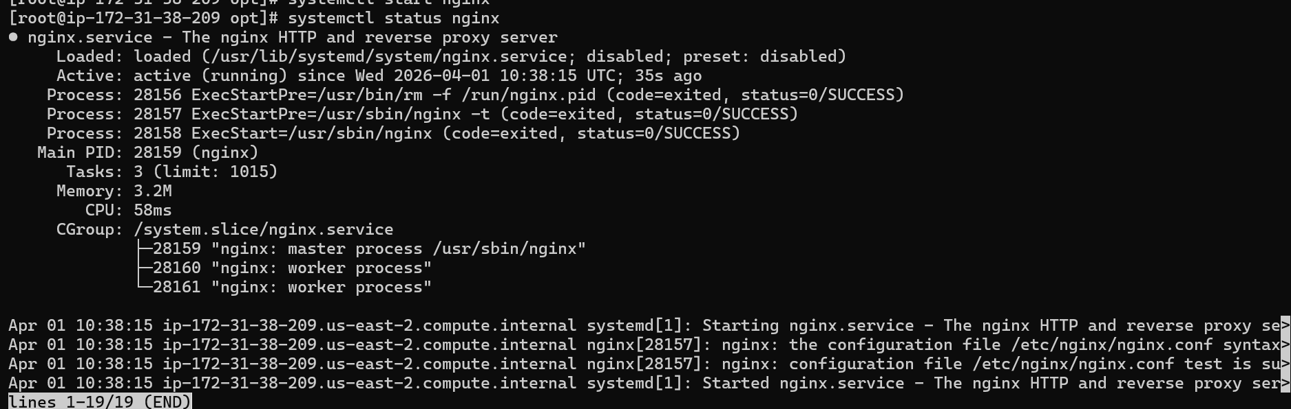
Nginx is now running on port 80
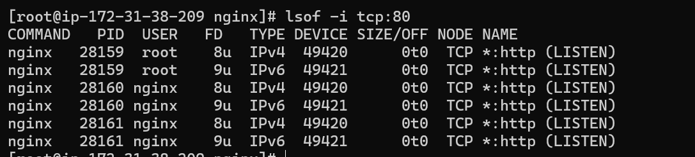
Now we need to change the port number from 80 to 81 by going to location /etc/nginx/nginx.conf
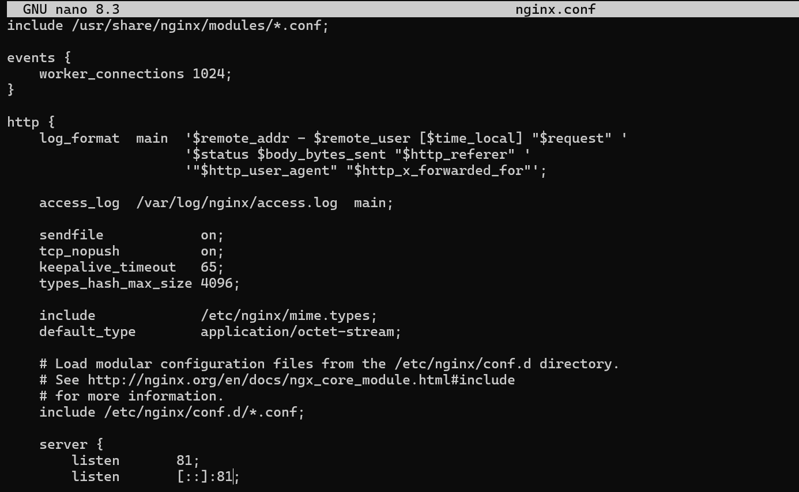
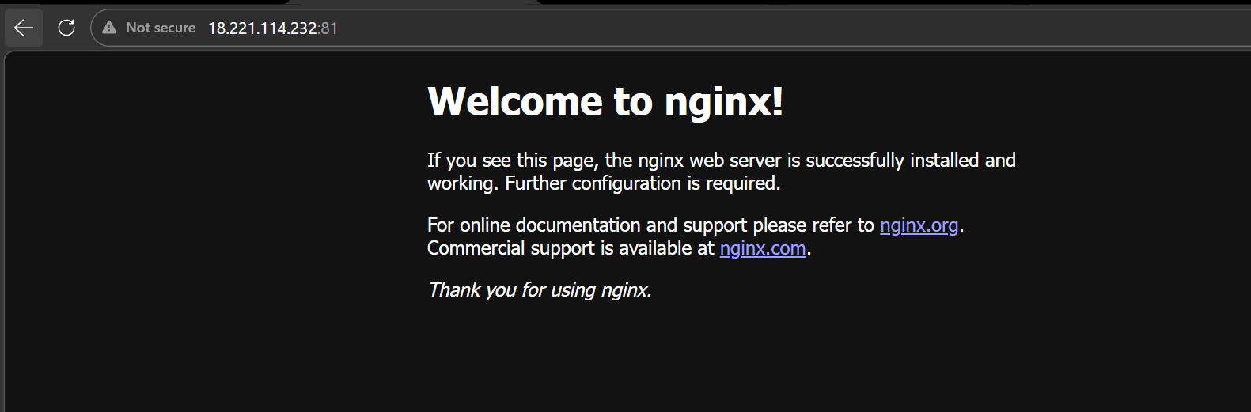

2.Deploying our own web page on nginx:
We need to go to location /usr/share/nginx/html and add our code in a index.html file
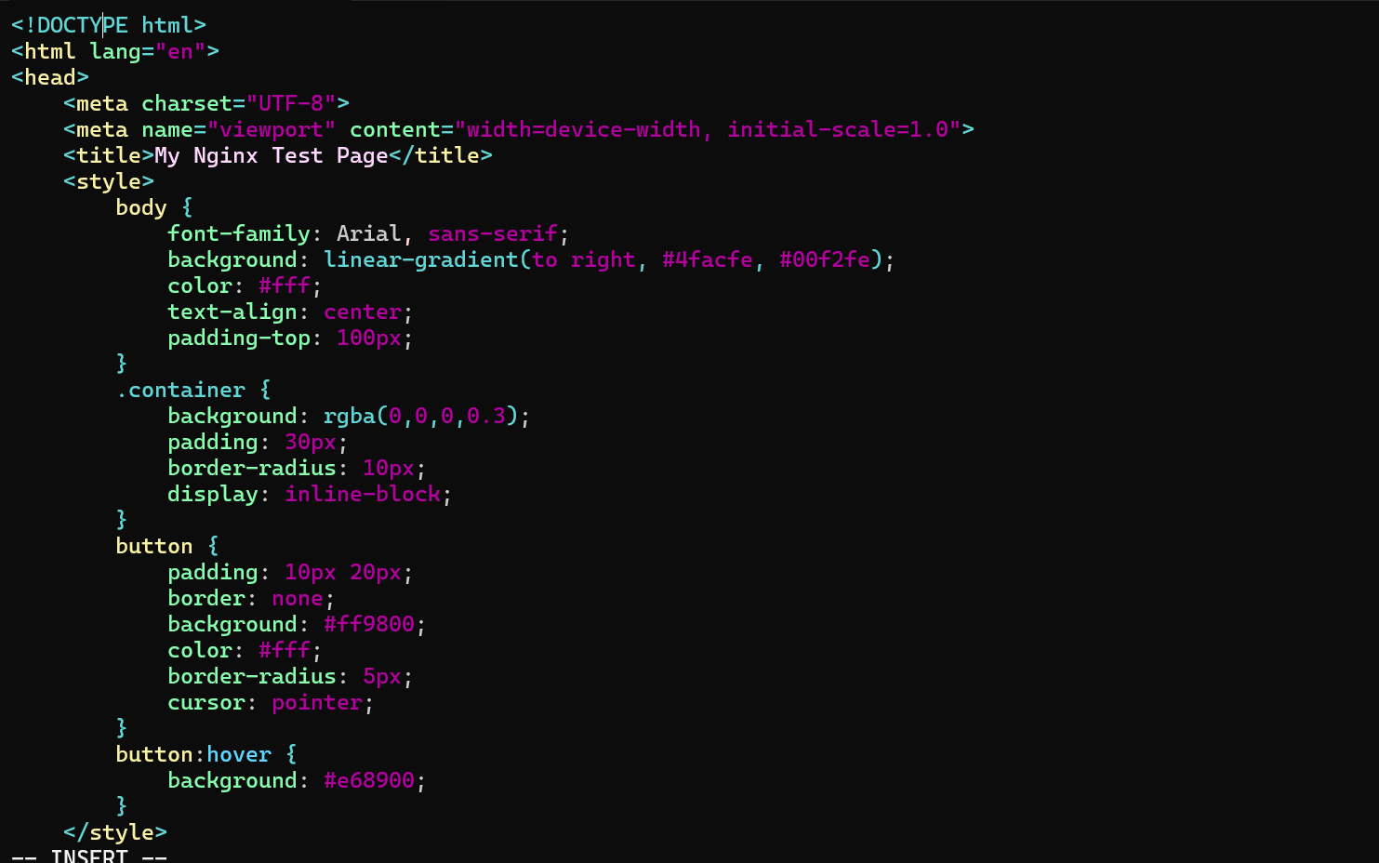


We have added our own web page on nginx

3.Installing Apache(httpd)
Now let’s install the httpd service
yum install is the command
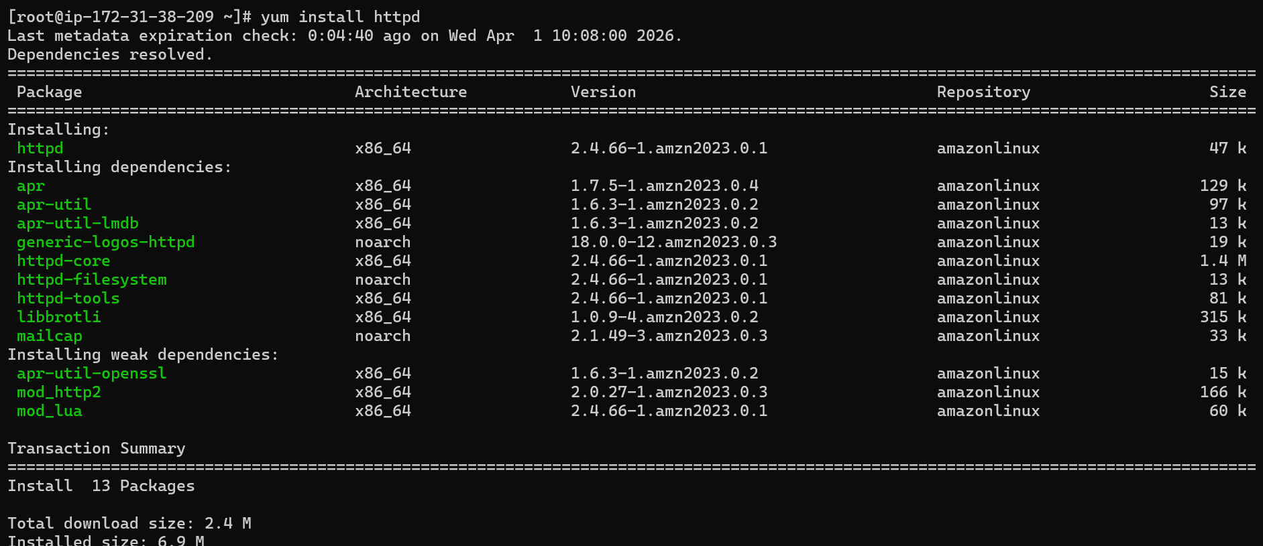
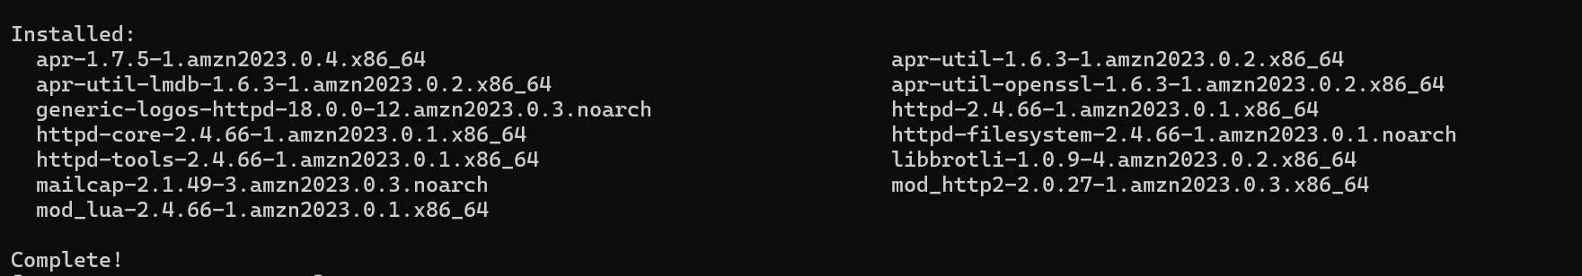
The httpd service is now installed.
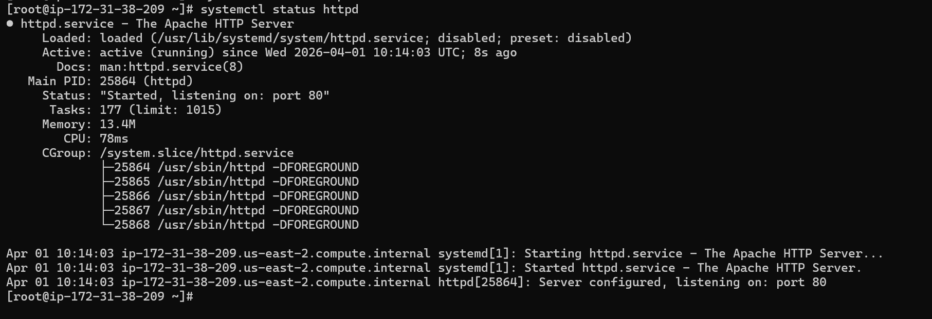
The httpd service is now running and listening on port 80.
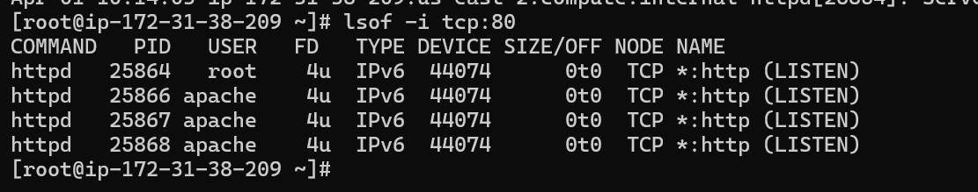
Changing the port to 82 by going to /etc/httpd/conf/httpd.conf
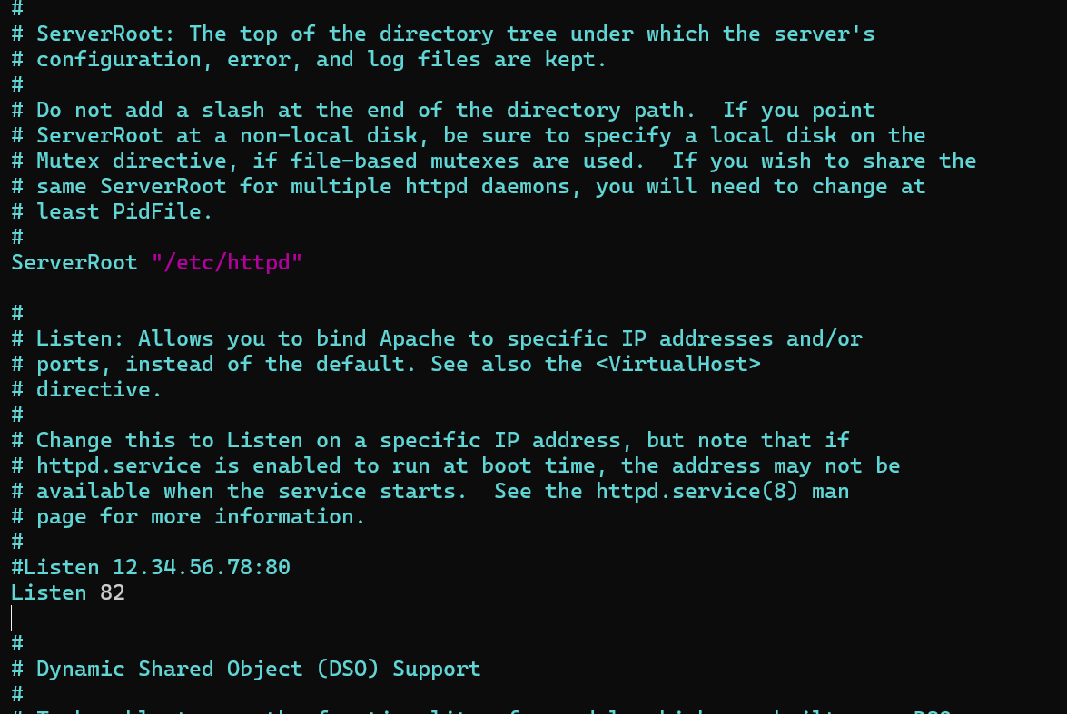

It is now listening to port 82.
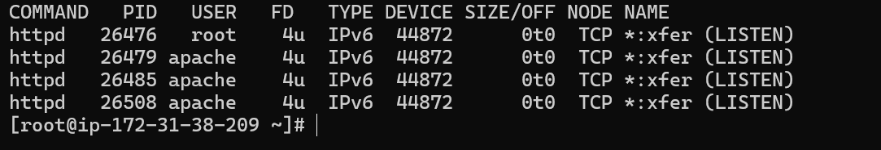

4.Deploying our own webpage on httpd.
We need to go to location cd /var/www/html and create a file index.html and add the sample code and save it the restart the service then we will be able to see the web page of our own.
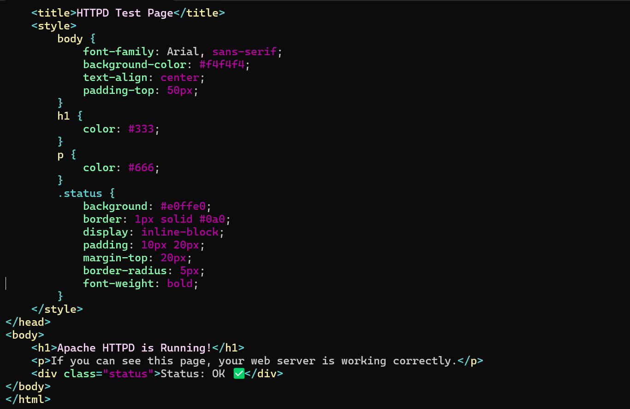

Now we can see that the browser is displaying our web page.
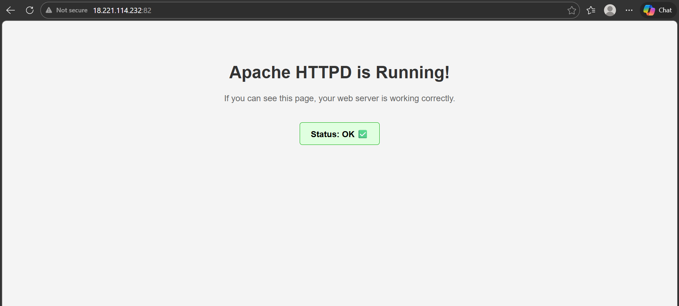

5.Installing Apache tomcat on port number 8082:

First we need to install Java as tomcat is developed in java we need to have java installed.
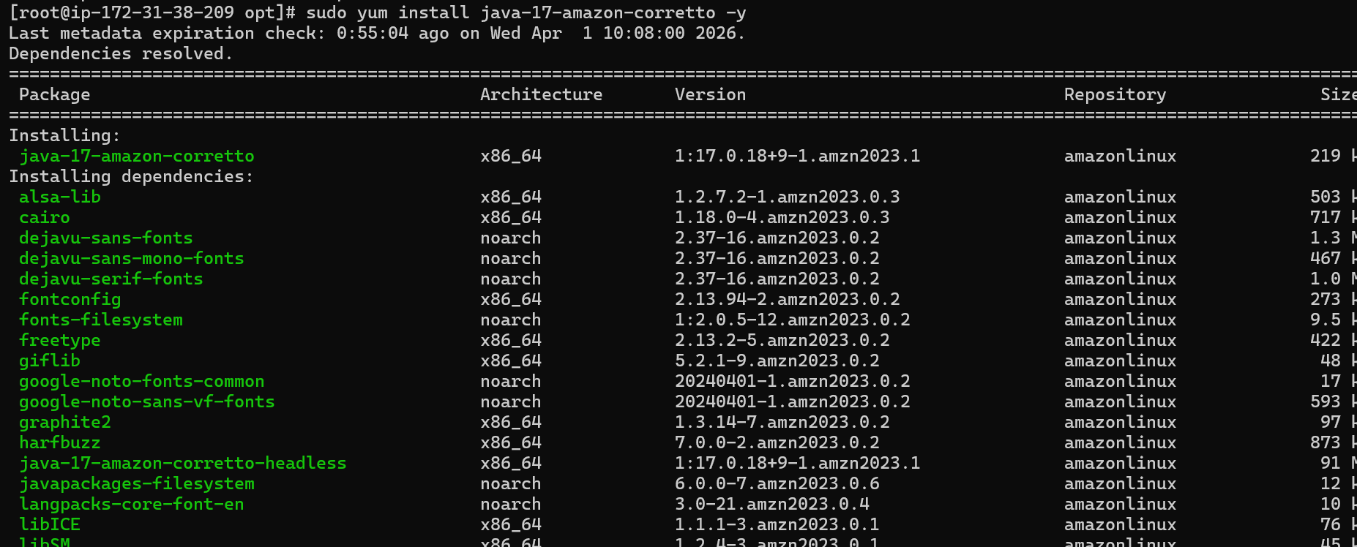
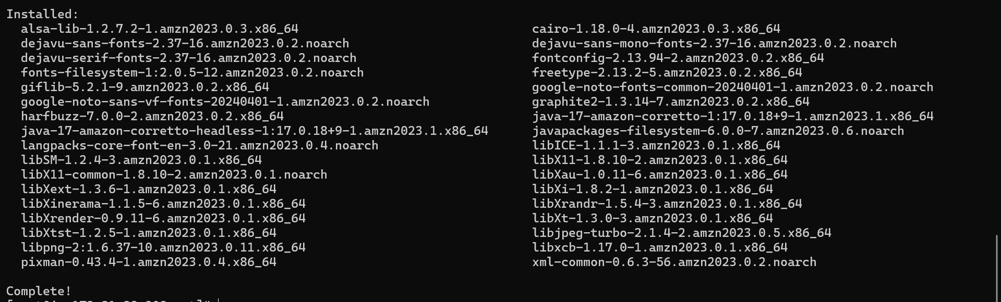
Java is now installed.

We need to download tomcat by using wget command.
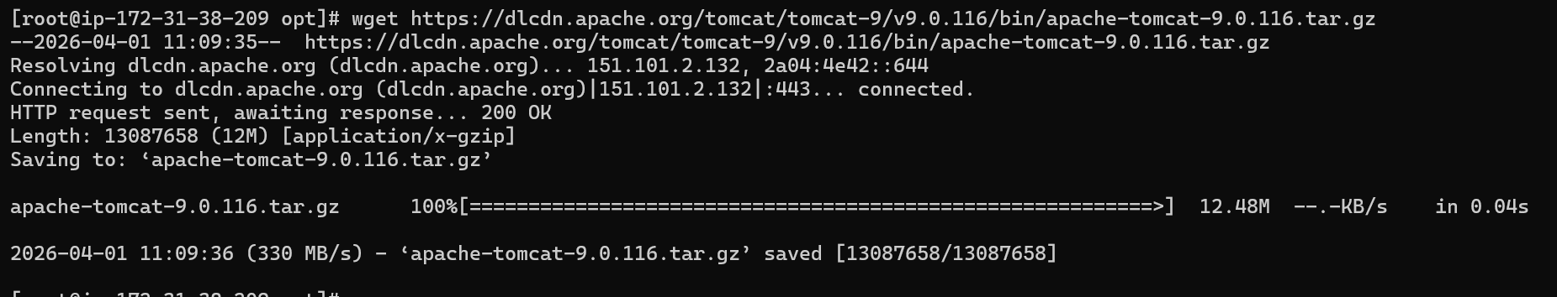
Extracting the tar file
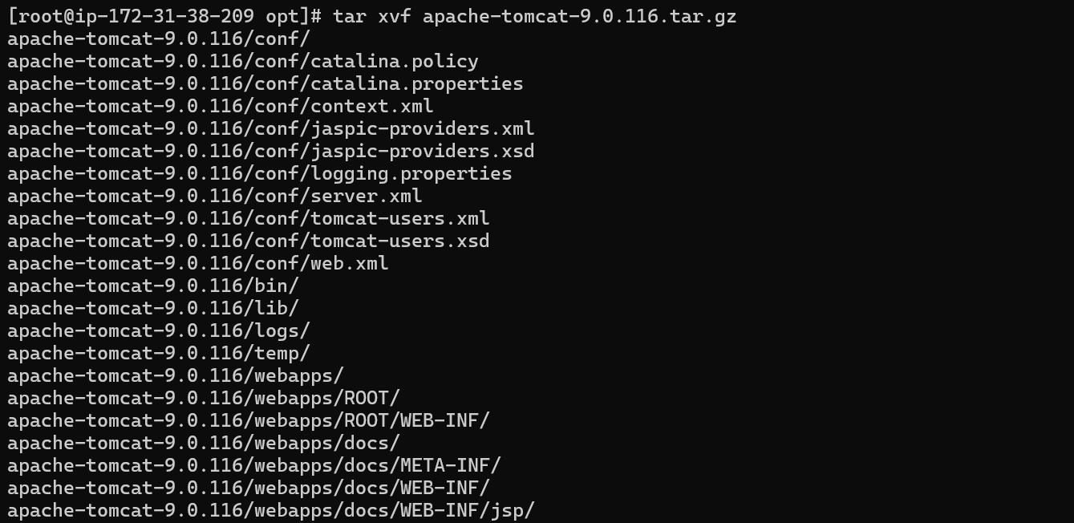
We need to go to location where the tomcat is installed and then we need to execute startup script.
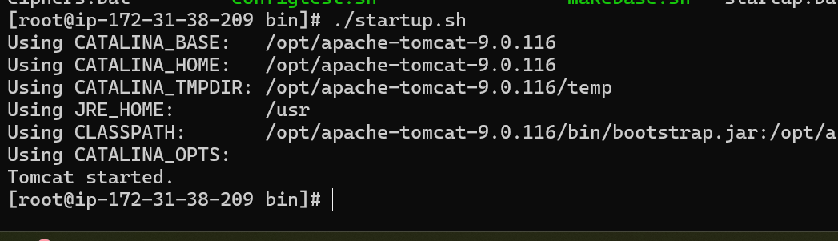
Tomcat is now started.

Changing the port number from 8080 to 8082:
We need to go to the directory where tomcat is downloaded and conf directory and then we need to edit server.xml file.
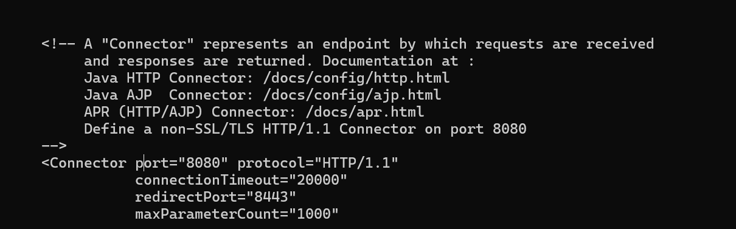
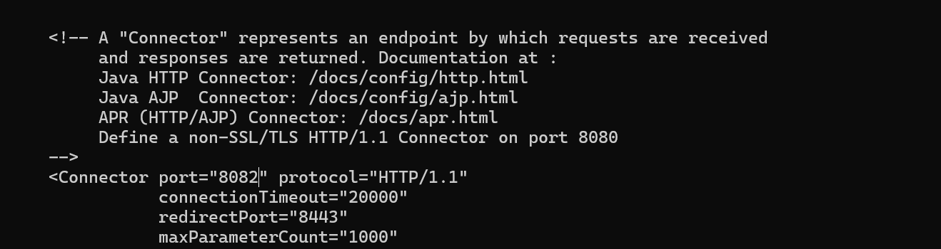

Apache tomcat is now running on port 8082.
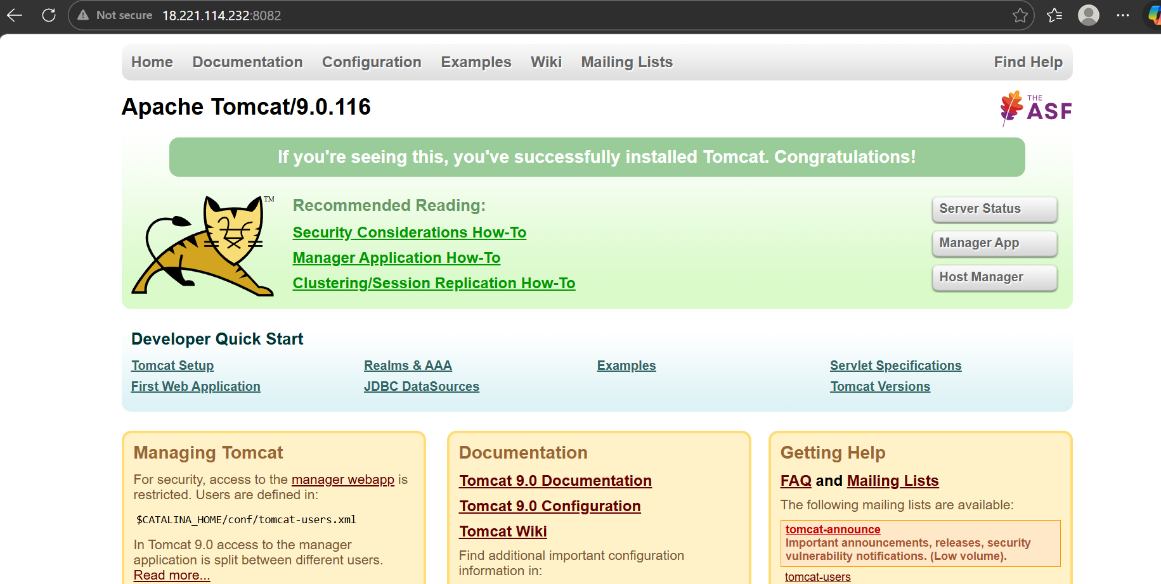

6.Deploying a sample web app on apache tomcat:
We need to go to the directory where tomcat is downloaded and then we need to go to webapps
There we can download our code in the same directory.
We can now check the webpage by going to our ip:port/sample.
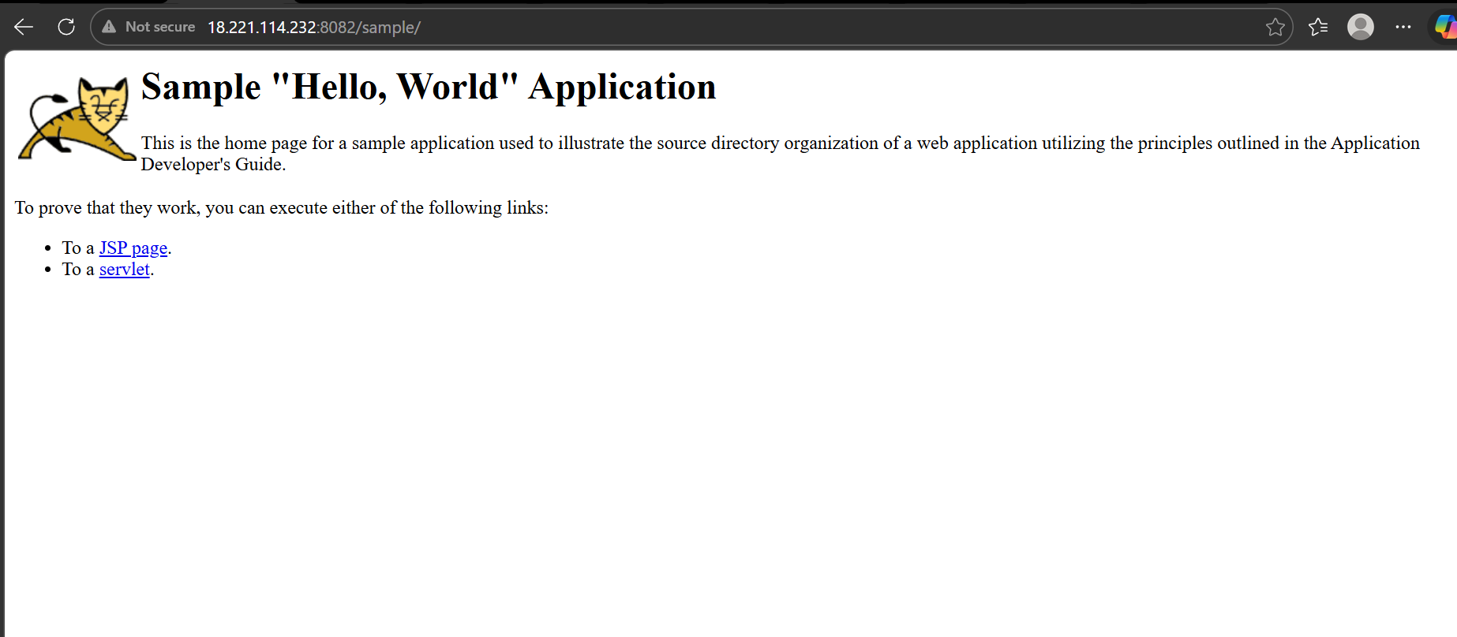

7.Create a tomcat.service file for tomcat.
We need to open the file at /etc/system/system/tomcat service and write the configuration
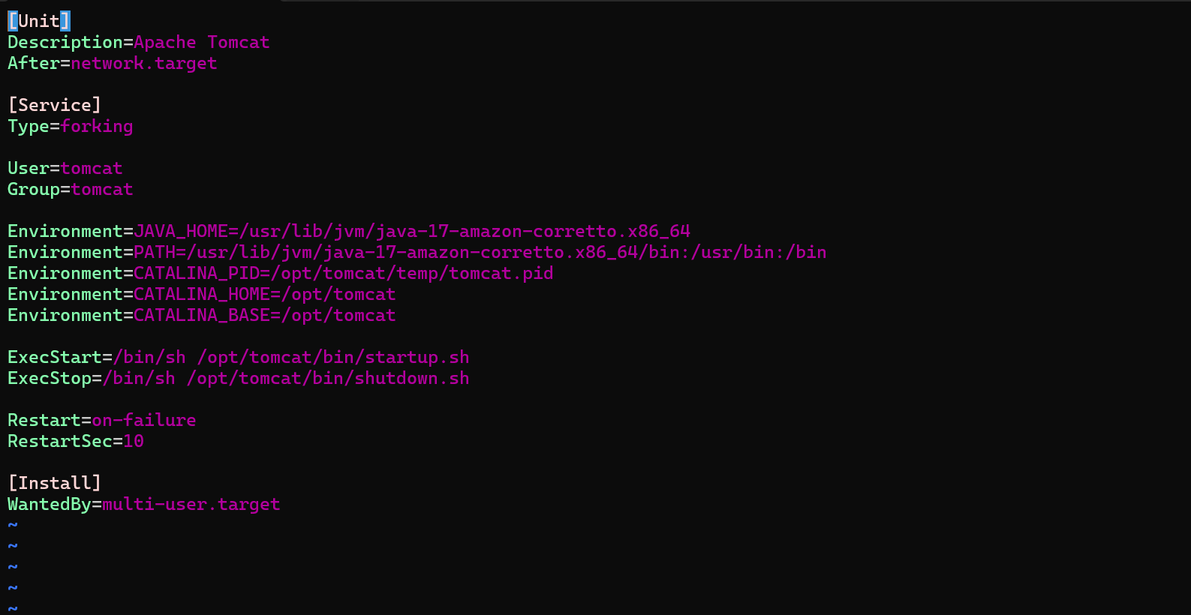
Then we need to reload system after that we will be able to use our file.
We can check it after starting the service with
systemctl restart tomcat
systemctl status tomcat
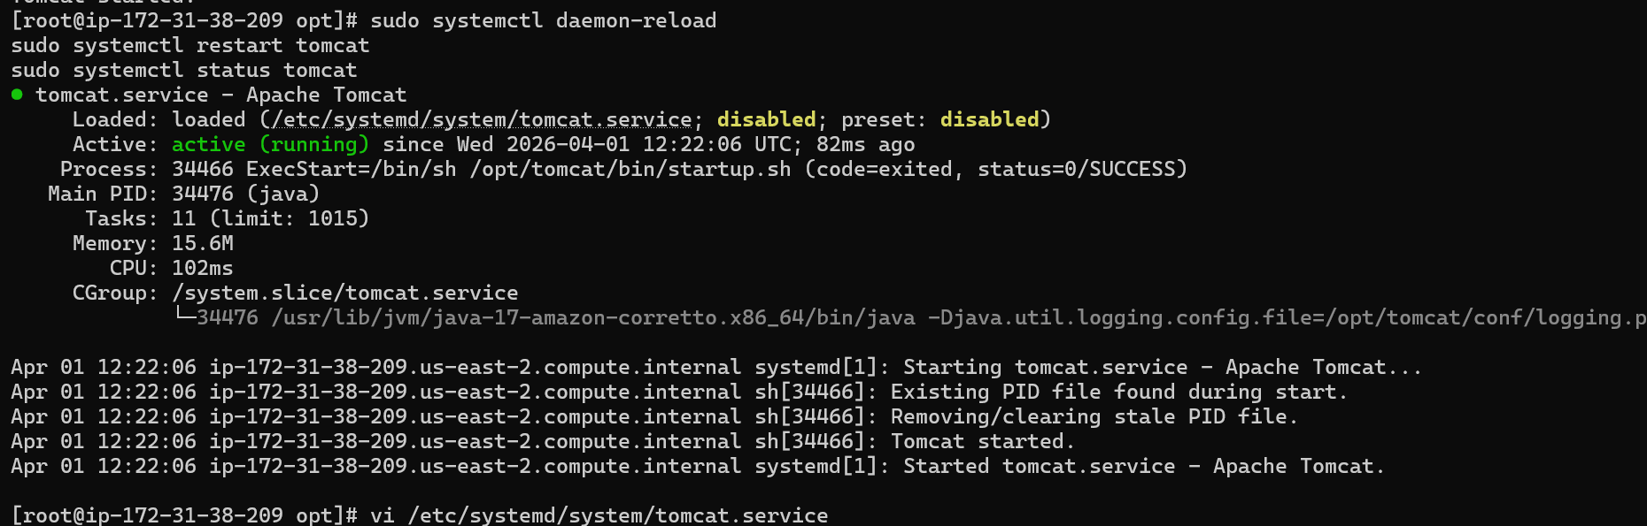
We can see that the service is now running.

8.Setting up HA proxy server:
SSH to the server 01
First let’s switch to root and update the packages.
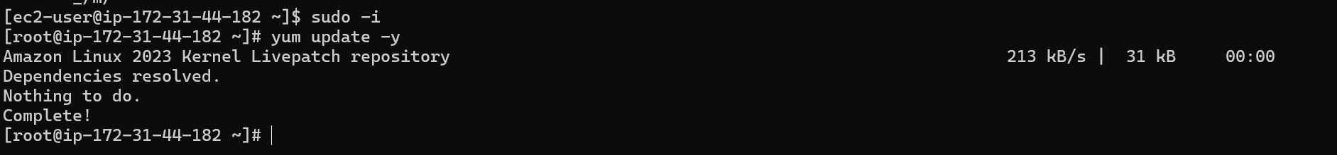

Now let’s install httpd
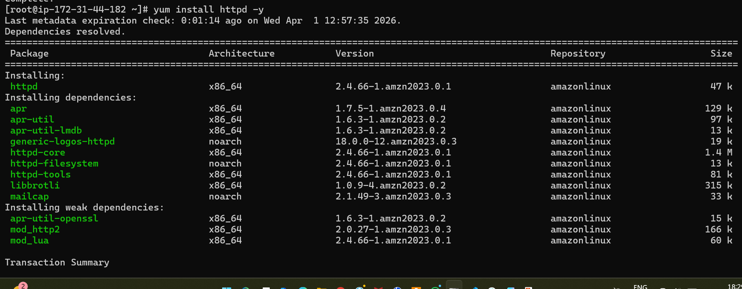
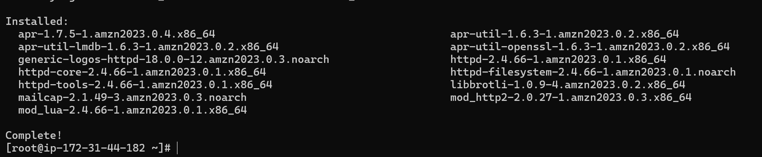
Httpd is now installed.
Now let’s go to vi /etc/hosts location
And add HA-Proxy-Servers IP address
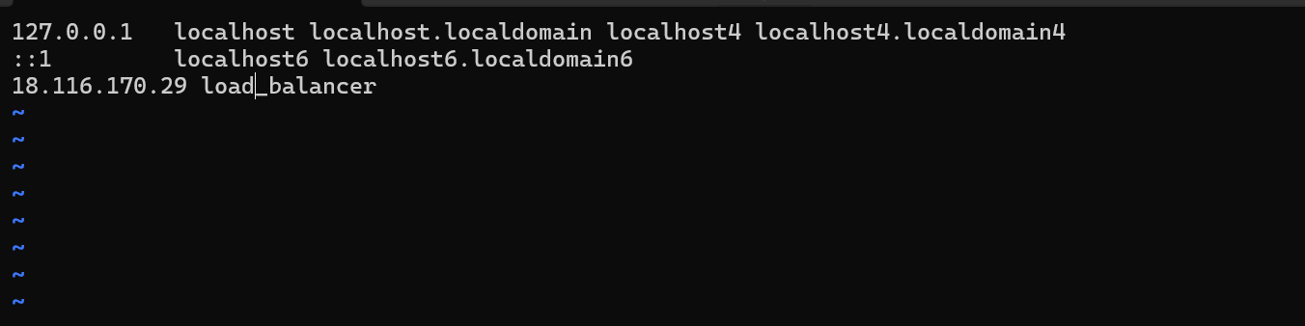
Now let’s try to ping the HA-Proxy-Server
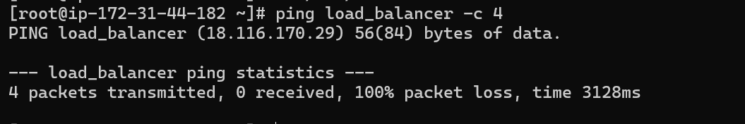
Now let’s start the httpd service
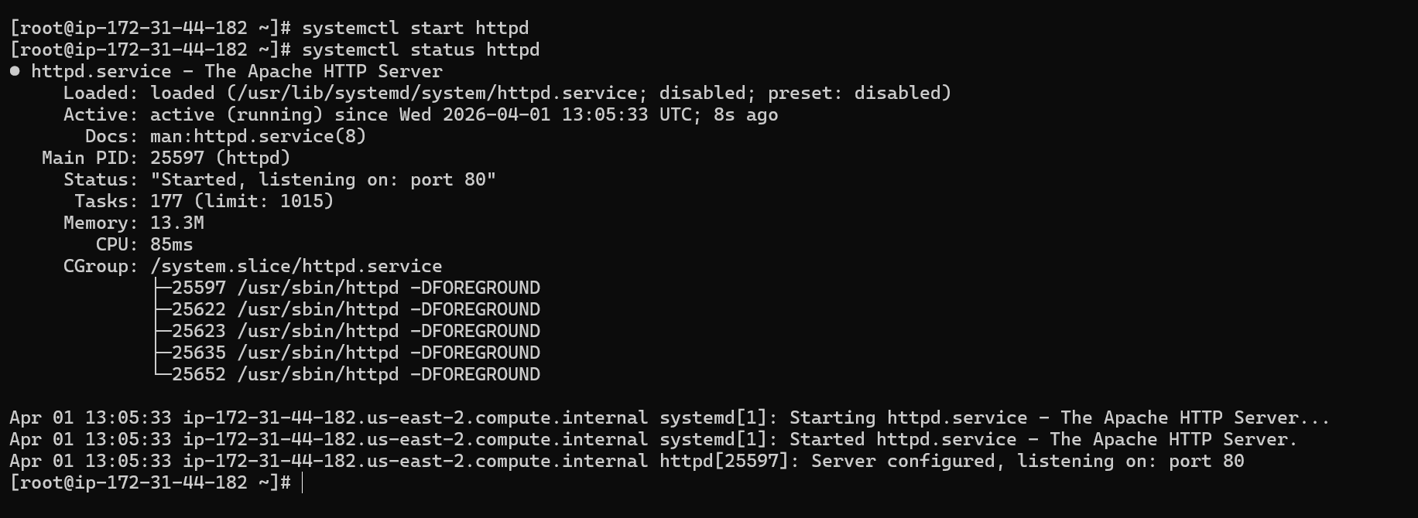
The httpd service is now running.

Now let’s SSH to server2 and do the configurations
First let’s update the packages.
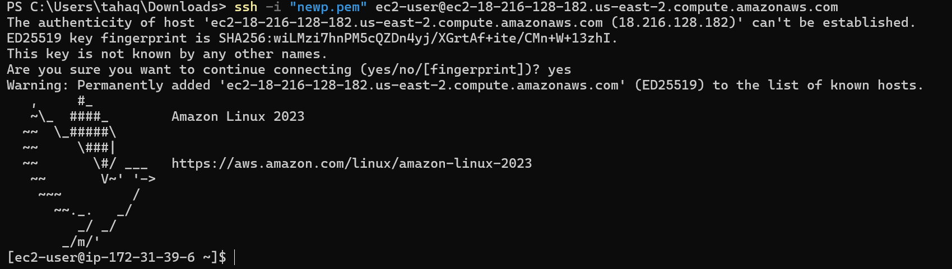
Also switch to root user as well.
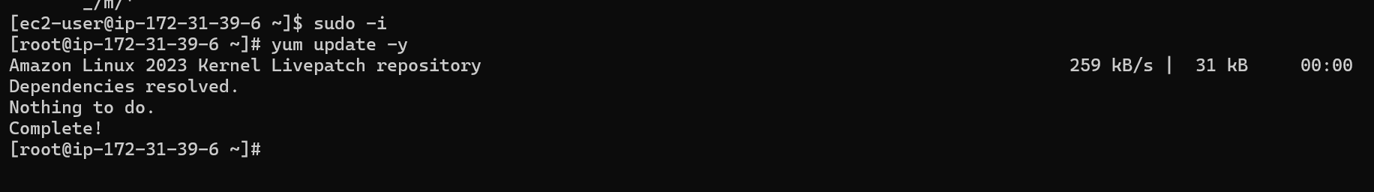
Packages are updated.

Let’s install nginx in the server2
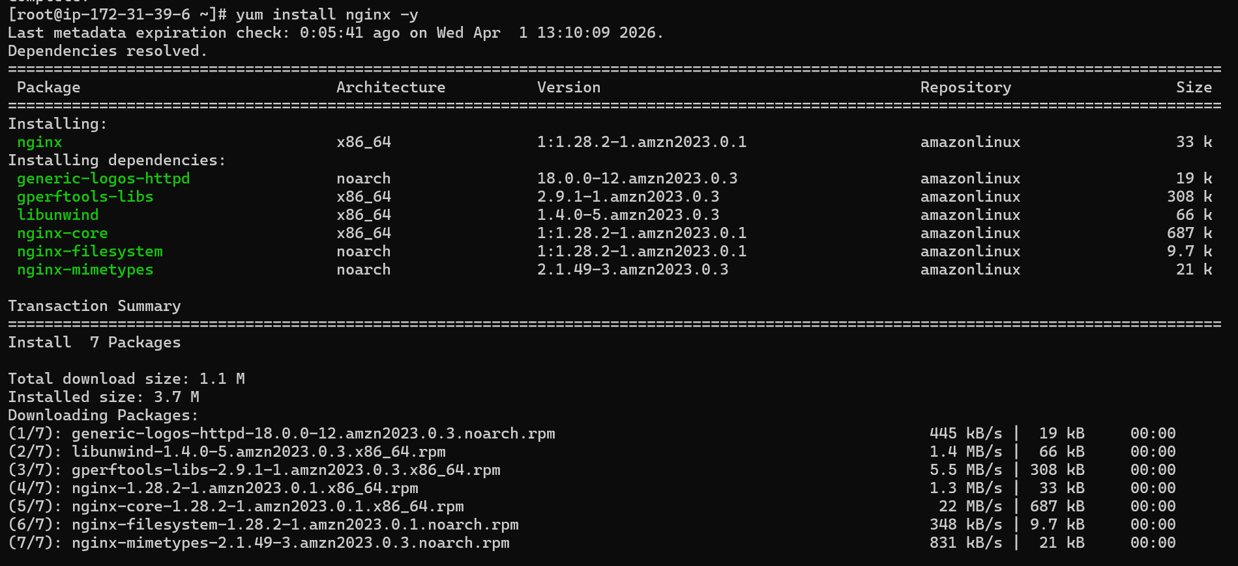
Nginx is now installed.
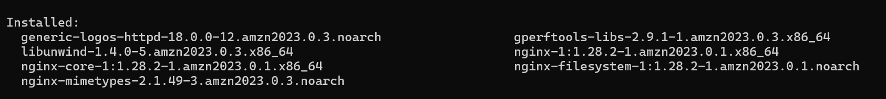
Now let’s add the HA-Proxy-Server’s IP in /etc/hosts file in server 2
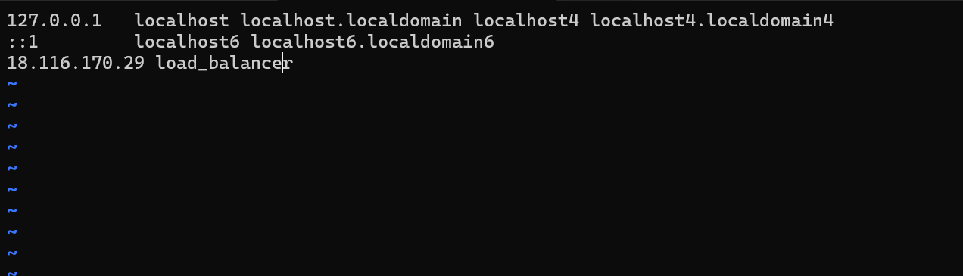
Now let’s try to ping the HA-Proxy-Server
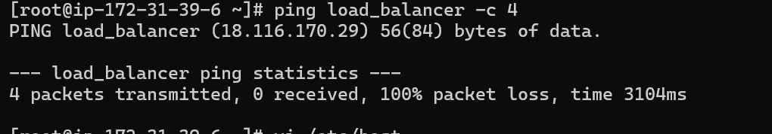

Now let’s setup the HA-Proxy-Server:
SSH to HA-Proxy-Server
After connecting to the proxy server let’s switch to root and update the packages
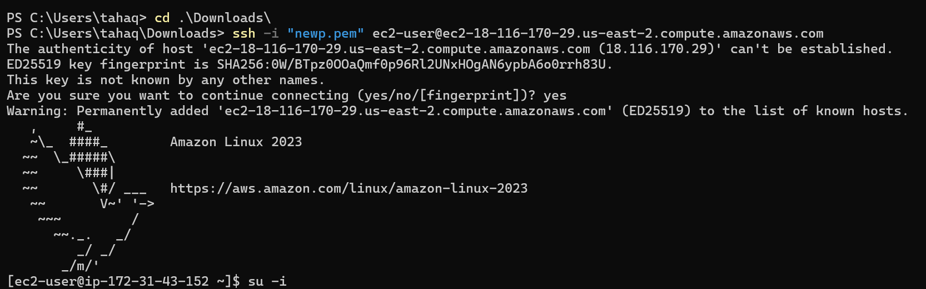
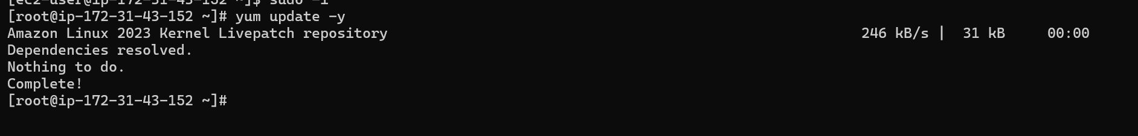
Now let’s install ha proxy in in HA-Proxy-Server
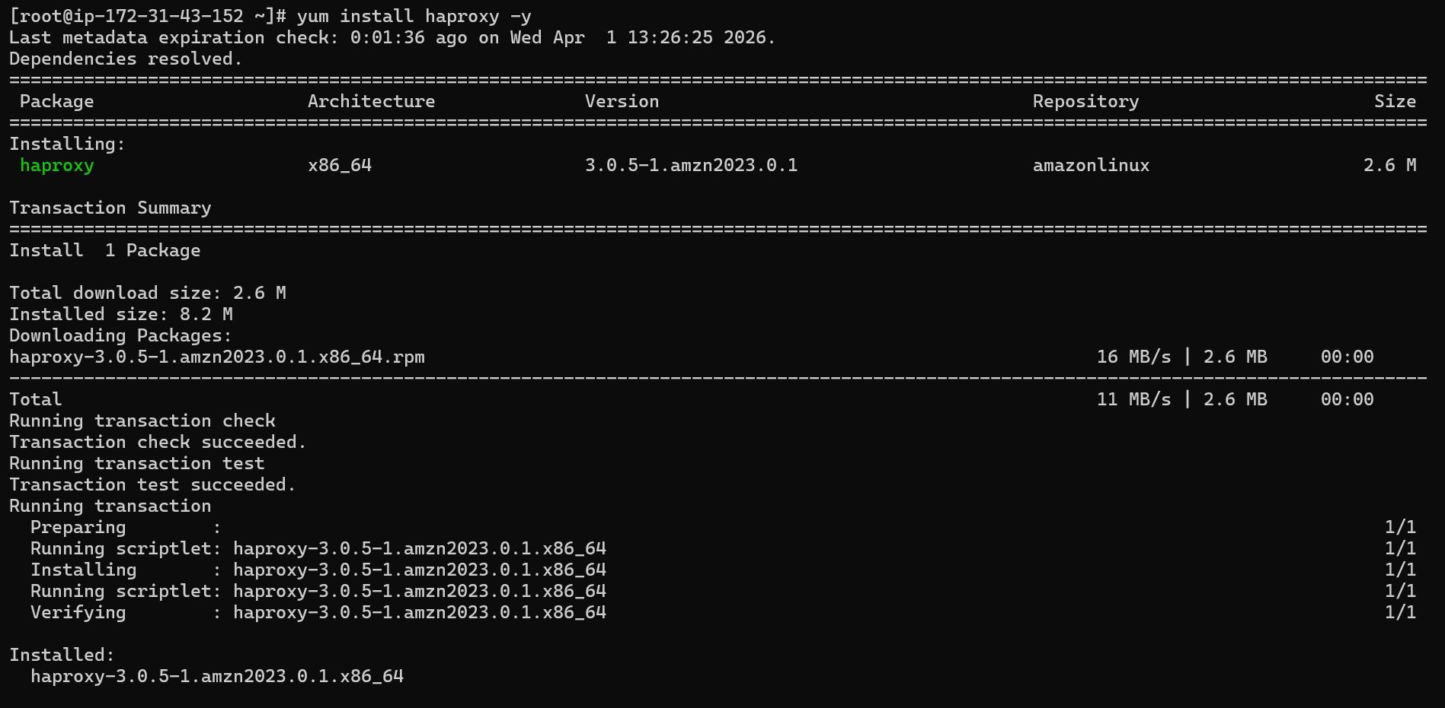
Ha proxy is now installed

Now let’s get to /etc/hosts file and add server1,server2 ‘s ip addresses
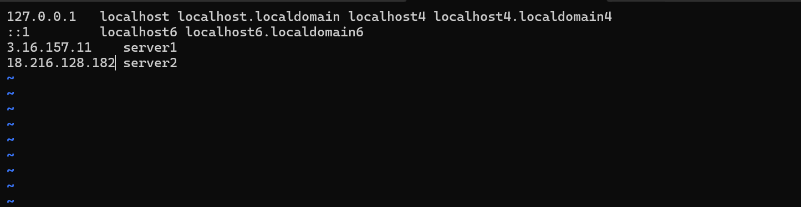
Now let’s add the server1 and server2 ip addressesin /etc/haproxy/haproxy.conf file
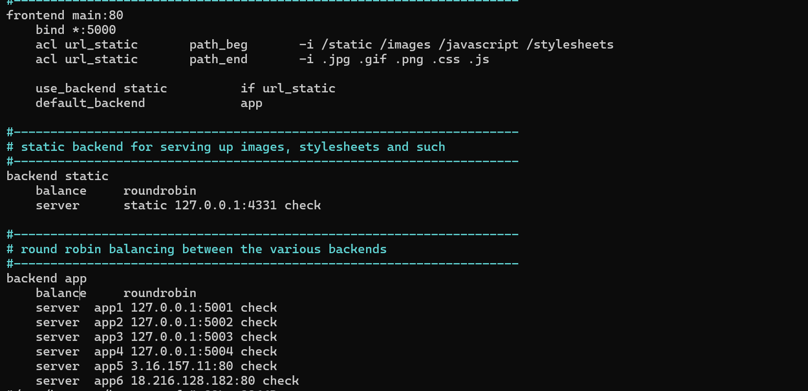
systemctl enable haproxy
systemctl start haproxy
systemctl status haproxy
the haproxy service is now active and running.
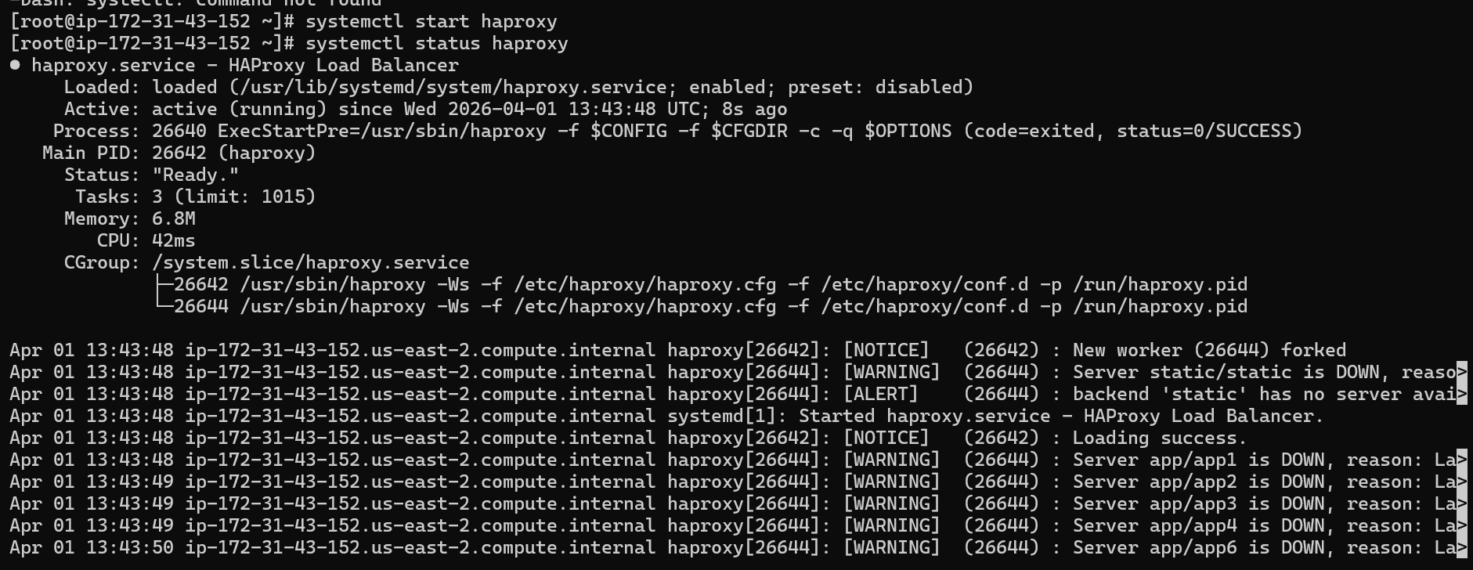

Now when we hit the load balancer’s IP the request will go to both the servers one after another.

